**1. Write a VBA code to select the cells from A5 to C10. Give it a name “Data Analytics” and fill the cells with the following cells “This is Excel VBA”**

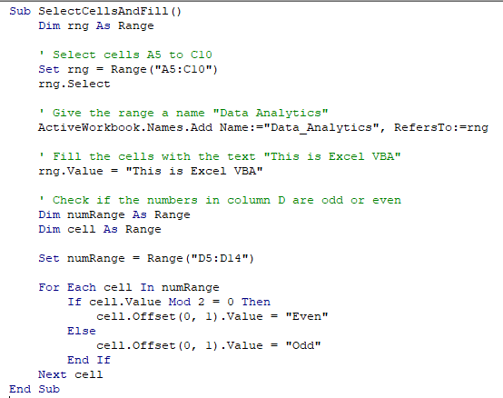

**2. Use the above data and write a VBA code using the following statements to display in the next column if the number is odd or even**

**a. IF ELSE statement**

**b. Select Case statement**

**c. For Next Statement**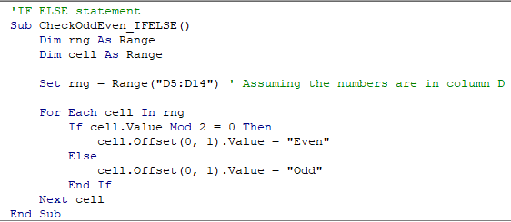

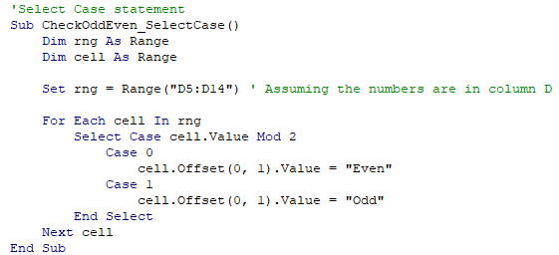

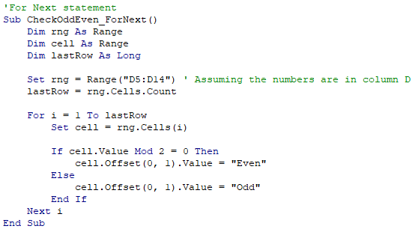

**3. What are the types of errors that you usually see in VBA?**

Syntax Errors

Runtime Errors

Logic Errors

Object Errors

Compile Errors

**4. How do you handle Runtime errors in VBA?**

**Enable Error Handling:**

At the beginning of your code or within the specific procedure where you want to handle errors, use the On Error statement to enable error handling. There are different options available, such as On Error Resume Next, On Error GoTo, and On Error GoTo 0.

**Use the On Error GoTo Statement:**

The On Error GoTo statement redirects the execution flow to a specific error handling routine when an error occurs.

You define an error handling routine by creating a label preceded by a colon (:) and specifying the label name after GoTo. For example, On Error GoTo ErrorHandler.

The error handling routine can be placed immediately after the code that might generate an error or at the end of the procedure.

**Implement Error Handling Routine:**

Within the error handling routine, you can handle the specific error condition, display informative messages, log errors, or take appropriate actions.

You can use the Err object to access information about the error that occurred, such as error number (Err.Number) and error description (Err.Description).

**Resume Execution:**

After handling the error, you can choose to resume normal execution of the code using the Resume statement.

The Resume statement can be used in different ways, such as Resume Next to continue execution from the line immediately following the line that caused the error, or Resume label to jump to a specific line or label in the code.

**5. Write some good practices to be followed by VBA users for handling Errors**

Enable Error Handling: Use the On Error statement at the beginning of your code or within specific procedures to enable error handling. This ensures that errors are captured and can be properly handled.

Be Specific in Error Handling: Handle errors with precision by using targeted error handling routines. Avoid using generic error handling that may hide or mask specific error conditions. Instead, create specific error handling routines for different types of errors that might occur.

Display User-Friendly Messages: Provide informative error messages that convey useful information to users or developers. The error messages should be clear, concise, and help users understand what went wrong and how to resolve the issue.

Log Errors: Consider implementing error logging mechanisms to capture and record error information. Logging errors can help in debugging, troubleshooting, and identifying recurring issues. Logging can be done to a text file, a database, or a custom error log.

**6. What is UDF? Why are UDF’s used? Create a UDF to multiply 2 numbers in VBA**

UDF stands for User-Defined Function. In VBA (Visual Basic for Applications), UDFs are custom functions created by the user to perform specific calculations or tasks that are not built-in functions provided by Excel or other applications. UDFs extend the functionality of Excel and allow users to create their own custom formulas.

Custom Calculations: UDFs can perform complex calculations or operations that are not achievable with built-in functions. Users can create UDFs to handle specific business or domain-specific calculations.

Automation: UDFs can automate repetitive tasks or calculations by encapsulating them in a single function. This enhances productivity and reduces manual effort.

Custom Data Manipulation: UDFs can be used to manipulate and transform data in specific ways that are not covered by built-in functions. This allows users to customize data processing according to their specific needs.

Enhanced Data Validation: UDFs can be used to create custom data validation rules to enforce specific conditions or constraints on input values.

